Annis Ferrey: Jubilee Award Winner 2018 18-21 Category

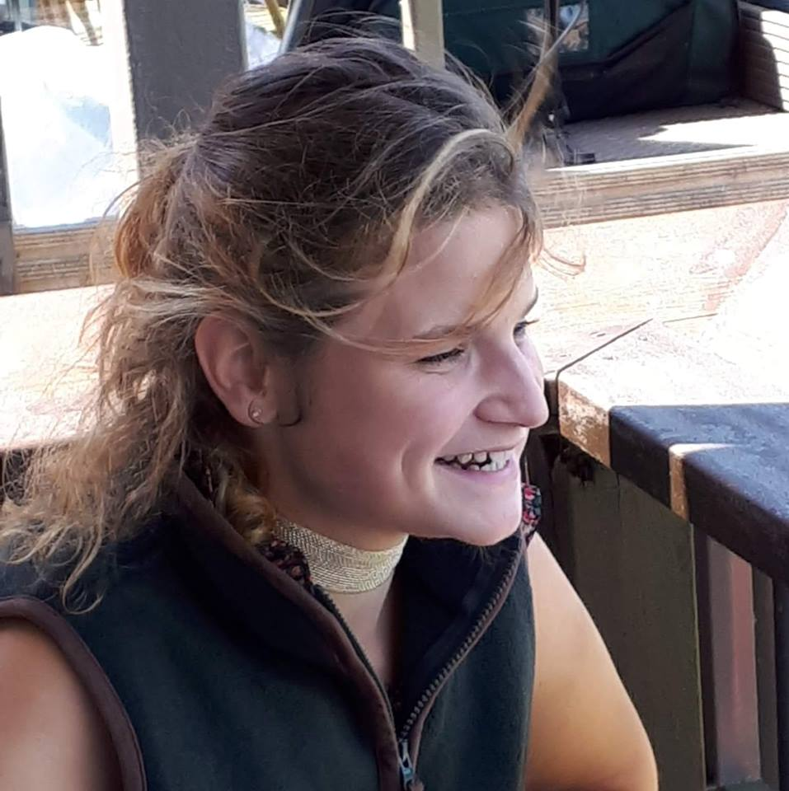

Introduction:
I am a 21-year-old Biochemistry student at the University of Sussex, about to progress into my 3rd year of study. Although originally from a horsey background, I have always had a keen interest in agriculture (since I have been on and around farms for most of my life) and as I’ve got older, I’ve realised that it’s an industry that I would love to have a career in. As a Biochemistry student, I am keen to find a way to combine my scientific knowledge with the problems facing agriculture in the modern world and (hopefully) contribute to solutions for the tricky issues’ farmers face providing food for an ever-increasing global population. My degree course has a significant amount of genetics content; an ever-broadening area of research for both arable and livestock farming. While my 3rd year project dissertation will be working on an online protein pesticides database. As I write this, my plan is to apply for the post graduate diploma in Agriculture at the RAU, so fingers crossed! I am also a keen member of the Petersfield branch of NYFC.
The Scholarship:
In September I was lucky enough to be awarded the Jubilee scholarship for the 18-21 category.
In my original proposal, I had wanted to spend the £500 grant to gain my ATV certificate. This would then allow me to apply for the YFC Limestone Downs Working scholarship in New Zealand. Sadly, this wasn’t to be as I was unable to locate any training providers or assessors willing to book me onto a course as an individual. As a result, I chose to relinquish the monetary grant.
All was not lost, however, as I was allocated Philip Halhead, M.D of Norbreck Genetics as my ‘livery buddy’.
Philip’s business is a combination of a 300 Holstein dairy herd, while the ‘genetics’ side focuses on sourcing and distributing the top beef genetics worldwide. Norbreck also uses embryo transfer technology.
I met with Philip in Cirencester, where we discussed what options would be open to me and where I could take my degree in order to embark on my desired career path. The meeting was invaluable! Initially, I was worried that not being from a farming background would put me at a disadvantage, but Philip assured me that with the way things were progressing, the next generation in agricultural research would need to combine an enthusiasm for agriculture with a scientific background in order to provide fresh and innovative perspectives. Philip’s passion for youth in agriculture is fantastic. We discussed consumer/supply chain demand and how the livestock industry is evolving to meet these needs and how genetics is increasingly playing a bigger role in producing a good quality standard product. Since Philip is at the cutting edge of the beef genetics industry in this country and travels extensively, he was able to provide me with names and contact details for a whole host of industry professionals, including those within AHDB, UK Sires, cattle breed societies and even some international researchers based in the USA. Philip was generous with his time and I remain in contact with him; I am looking forward to learning more from his expertise and passion for the industry.
Being able to ask for help and advice from somebody in his position is hugely encouraging and helpful for somebody such as myself, just beginning to forge my career path. In the future, I would like to spend some time shadowing at AHDB and/or the UK Sires stud operation alongside my university studies. Through Philip being allocated as my ‘livery buddy’ I have been made aware of the many opportunities and pathways there are available to me within the sector and the sort of things future employers would be looking for. I am hoping that by liaising with Philip I will be able to gradually build my network of contacts and increase my experience, to enable me to eventually secure a job where I will be able to use my academic/biochemical knowledge to aid the sustainable expansion and progression of farming.
I would like to thank NYFC and the Worshipful Company of Farmers for providing me with this opportunity. Moreover, many thanks to Philip for agreeing to mentor me. I would urge anybody considering the scholarship to apply. You have nothing to lose and possibly everything to gain!

